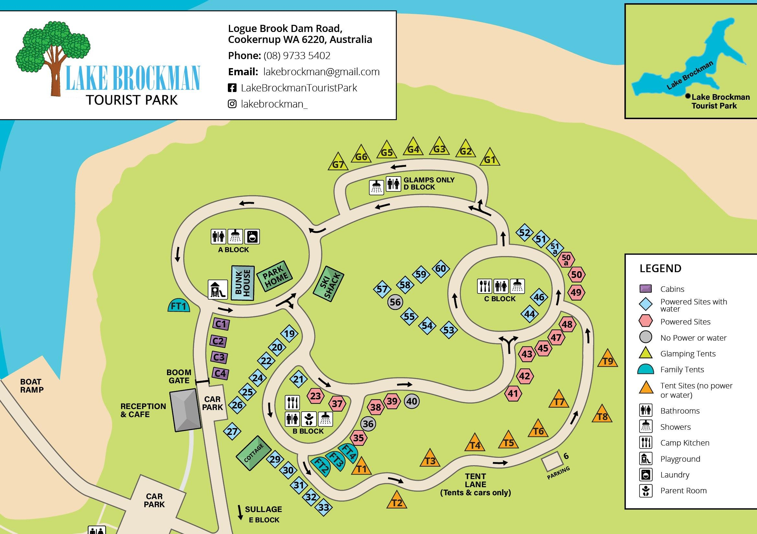
LAKE BROCKMAN TOURIST PARK MAP & INFORMATION PLEASE FOLLOW US ON INSTAGRAM AND FACEBOOK
CABINS X (4) $145 per night – linen not included (linen hire $20 QB or $18 SB per bed) - Sleeps 6 people, 1 queen size bed in one room a Kitchenette (with microwave, bar fridge, gas cooker, toaster, kettle, crockery & cutlery), in the next room there are 2 single bunk beds. There is NO bathroom or toilet in these Cabins. BBQ. Reverse cycle air-conditioning BUNKHOUSE X (1 ) $205 per night – linen not included (linen hire $20 QB or $18 SB per bed) -Sleeps 8 people, it is one large room with 2 queen size beds and 2 single bunk beds and a small Kitchenette (with microwave, bar fridge and gas cooker). (BBQ. There is NO bathroom or toilet in the Bunkhouse. Reverse cycle air-conditioning.
PARKHOME X (1) $265 per night (All linen included) - Sleeps 5 people, 1 queen size bed in one room, kitchen/living room has a double bed and single bed above it. The Park home has its own bathroom and toilet. A fully equipt kitchen with a full-sized oven and fridge. BBQ. The Park home is airconditioned. SKI SHACK X (1) $195.00** per night – linen not included (linen hire $20 QB or $18 SB per bed) - Sleeps 6 people, 1 Queen size bed and 2 single bunk beds, a small kitchenette (with microwave, bar fridge and gas cooker). There is NO bathroom or toilet in the Ski shack. The Ski Shack is air-conditioned and has outdoor dining area and BBQ area. **DOGS PERMITTED in ski shack only - $20 per dog per night (Maximum 2 dogs) COTTAGE X (1) $295.00 per night (All linen included) - Sleeps 6 people with a Queen bed in one room, a Double bed and a single bunkbed in another room. Can sleep 8 as includes sofa bed – extra $15 pp. The cottage has a kitchen/dining area and a small lounge. The kitchen has a microwave, full fridge/ half freezer, oven and stovetop, Nespresso coffee machine, toaster, kettle and crockery & cutlery. The bathroom consists of a shower and basin but the toilet is shared at the nearby ablution block. Also, an undercover verandah, outdoor table & chairs and BBQ (plus there's a firepit area for the winter months). The Cottage has reverse cycle air conditioning.
LUXURY FAMILY TENT (with a view) x (1) $380.00 per night (All linen included)
Our luxury family tent sleeps 5 people and overlooks Logue Brook Dam. It’s equipped with a Queen bed, bunkbed (double with single above), a kitchenette with fridge/ half freezer, cutlery, crockery, air fryer, toaster, kettle, microwave and outdoor BBQ plus a fridge and Nespresso coffee machine. The luxury tent also has its own bathroom with a decked porch area and fire pit (for use during the winter months).
FAMILY TENTS X (3) $235.00 per night Our Family Tents sleep 4 people and overlooks the beautiful state forest. It’s equipped with a Queen bed (linen provided) bunk bed (linen extra) a small kitchenette with cooking equipment and located close to our all-new camp kitchen which provides a BBQ area. The tent also has a bar fridge and Nespresso coffee machine and all you need to have a beautiful camping experience with your family. Each tent has decking and a fire pit area (for use during the winter months)
GLAMPING TENTS X (7) $220.00 (All Linen included) - Sleeps 2 adults only, Queen size bed (with linen and towels), tea and coffee facilities including a Nespresso machine, bar fridge, private balcony with BBQ and tables and chairs, cutlery & crockery provided and a fire pit. There are shared amenities and a camp kitchen a short walk away
INFORMATION FOR ALL ACCOMMODATION – INCLUDING GLAMPS & FAMILY TENTS
Definitely NO DOGS ALLOWED in ALL Accommodation including Family & Glamping tents. (DOGS PERMITTED in ski shack only )for accommodation that linen is not supplied it can be hired. a linen set (sheet set, doona , towel and pillows) for $18.00 SB or $20 QB - per bed or you can bring your own. A one night’s deposit is required when making a booking (OUR REFUND POLICY IS ON OUR WEBSITE).
CAMPING (Tent or Caravan) Dogs $2 per night – allowed on all campsites p.n. = per night p.c.p.n. = per child per night POWERED SITE : $50.00 per site p.n.up to 2 adults, $18.00 per additional adult p.n. and children (6-15years) $8.00 p.c.p.n. POWERED SITE NO WATER: $48.00 per site p.n.up to 2 adults, $18.00 per additional adult p.n. and children (6-15years) $8.00 p.c.p.n. UNPOWERED NO WATER : $42.00 per site p.n.up to 2 adults, $15 per additional adult p.n. and children (6-15years) $8.00 p.c.p.n TENTLANE NO POWER NO WATER:$42.00 per site up to 2 adults, $15.00 per additional adult and children (6-15years) $8.00 p.c.p.n. The Café is now OPEN! We have Devonshire Tea’s, fresh cooked hot food, great coffee, ice cream, snacks, beverages and milk. Generators 8am – 9pmCALL 9733 5402 IN OFFICE HOURS OR ONLINE – www.lakebrockman.com.au

